Tajuk Projek: Sistem Jualan Online Telecommunication Equipment (E-Commerce)

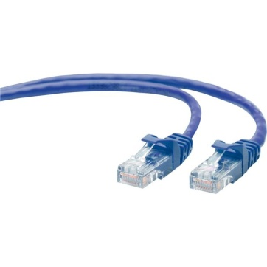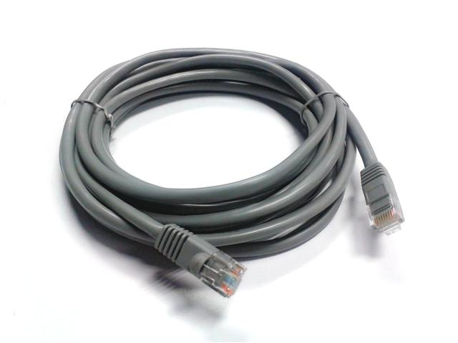

**1.RJ 46 UTP LAN Cable**

Product Specifications :-

High Quality Cat 6 Gigabit Custom Made Cable

23AWG Solid Bare Copper

Blue/Grey Colour PVC Jacket

Pass Fluke Channel Test

Meets ISO 9001 / UL / CE / FCC / RoHs

Available In 5m/10m/12m/13m

**Price : RM20**

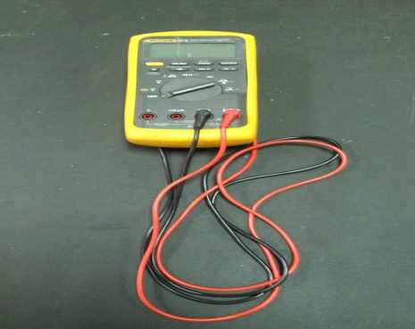

**2.FLUKE Multimeter 83V Series**

Features and benefits of the Fluke 83V series

Unique function for accurate voltage and frequency measurements on adjustable speed motor drives and other electrically noisy equipment (87V)

Built-in thermometer conveniently allows you to take temperature readings without having to carry a separate instrument (87V)

Optional magnetic hanger for easy set-up and viewing while freeing your hands for other tasks

Large digit display with bright, two-level backlight makes the 80- Series V significantly easier to read than older models

**Price : RM1000**

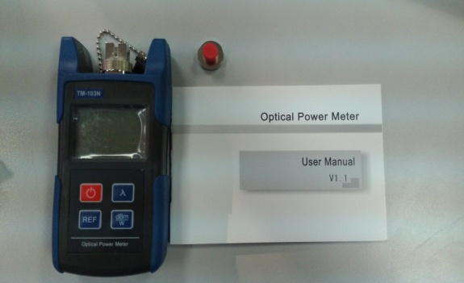

**3.Optical Power Meter**

Product Specification

Measurement range -70+10dBm,calibrated wavelengh : 850nm,1300nm,1310nm,1490nm,1550nm,1625nm

Measurement range -50+26dBm,calibrated wavelengh : 850nm,1300nm,1310nm,1490nm,1550nm,1625nm

**Price : RM 400**

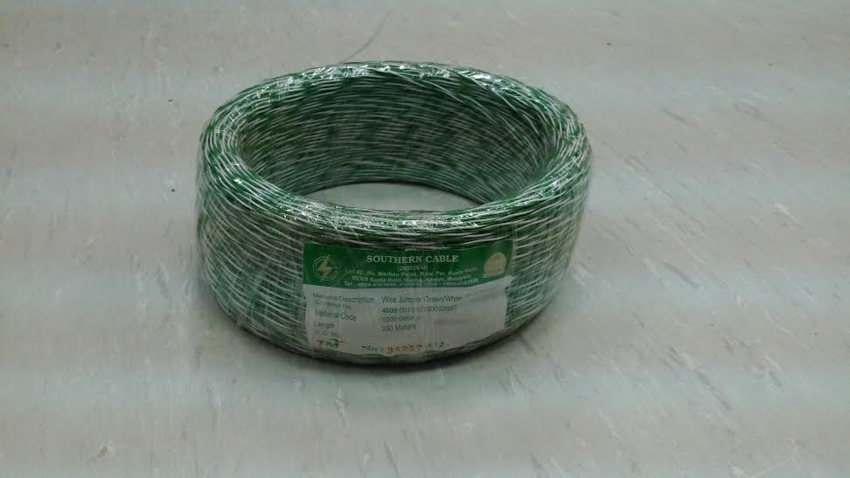

**4.Jumpering Cable**

Product Specification

Green and white colour

Length 250 metre

**Price : RM 15**

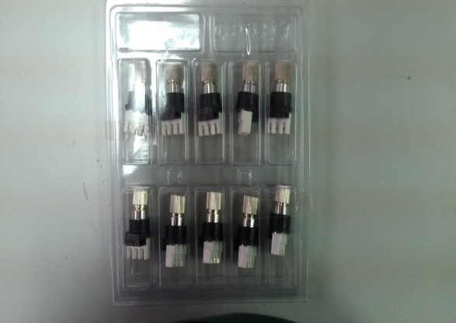

**5.BNC Connector**

Features

Multi purpose connector between jumper cable

**Price : RM 25**

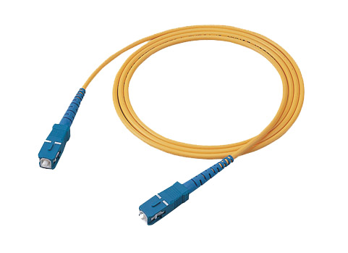

**6.Patch Cord**

Features:

Low Insertion Loss

Easy to handle

Stable environment

Plug and play.

High quality

Suitable for applications in Telecommunications, Unifi, LAN, FTTH, Optic fiber sensors, Testing instruments and etc

**Price : RM20**

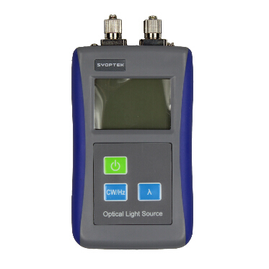

**7.Optical Light Source**

Description:

TL-512 Optical Optic Light Source wavelength

1310/1550nm

Features:

-CW,270Hz,1KHz,2KHz.

-Compact size, backlight LDD display.

-Modulation at other wavelengths.

-High stability of the output power.

-Alternative 10 minutes Auto-off function

conserving battery life.

Application:

-Maintenance CATV

-Maintenance in Telecom

-Fiber Optic Lab Testing

-Other Fiber Optic Measurement

**Price : RM600**